**#Week (2)** Configuring a Dial-Up IPsec VPN Between Two FortiGate Devices

1. CREATE phase 1 and phase 2 negotiations

Click **VPN** > **VPN Tunnels** > **Create New** > **Custom IPsec tunnel**.

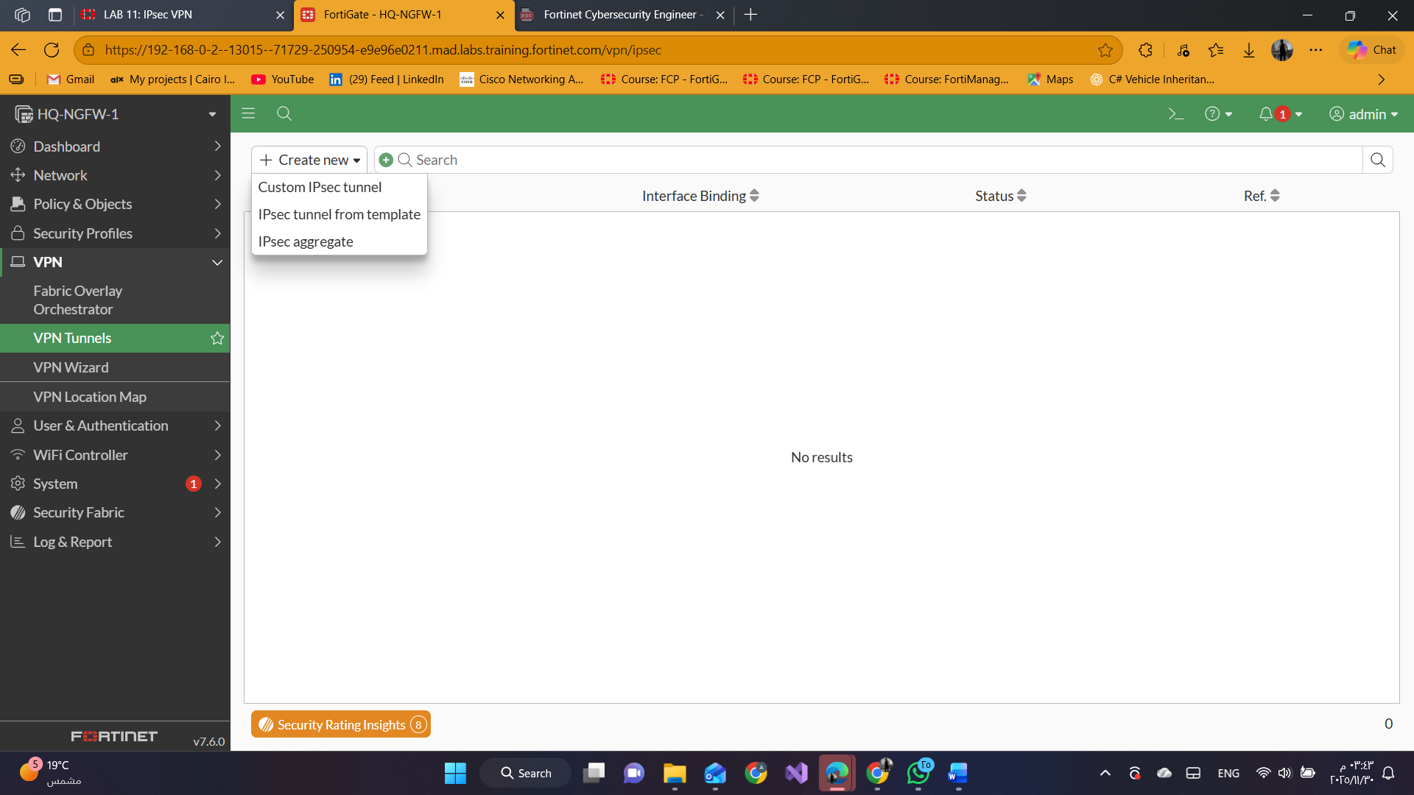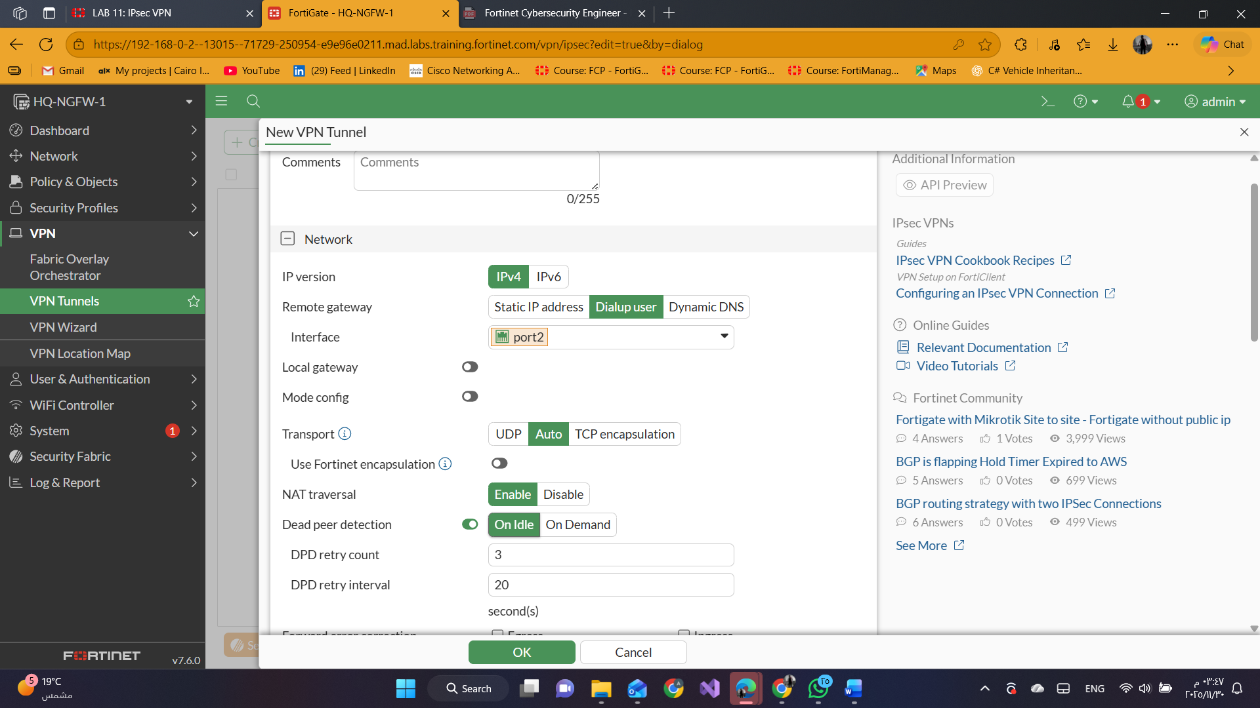

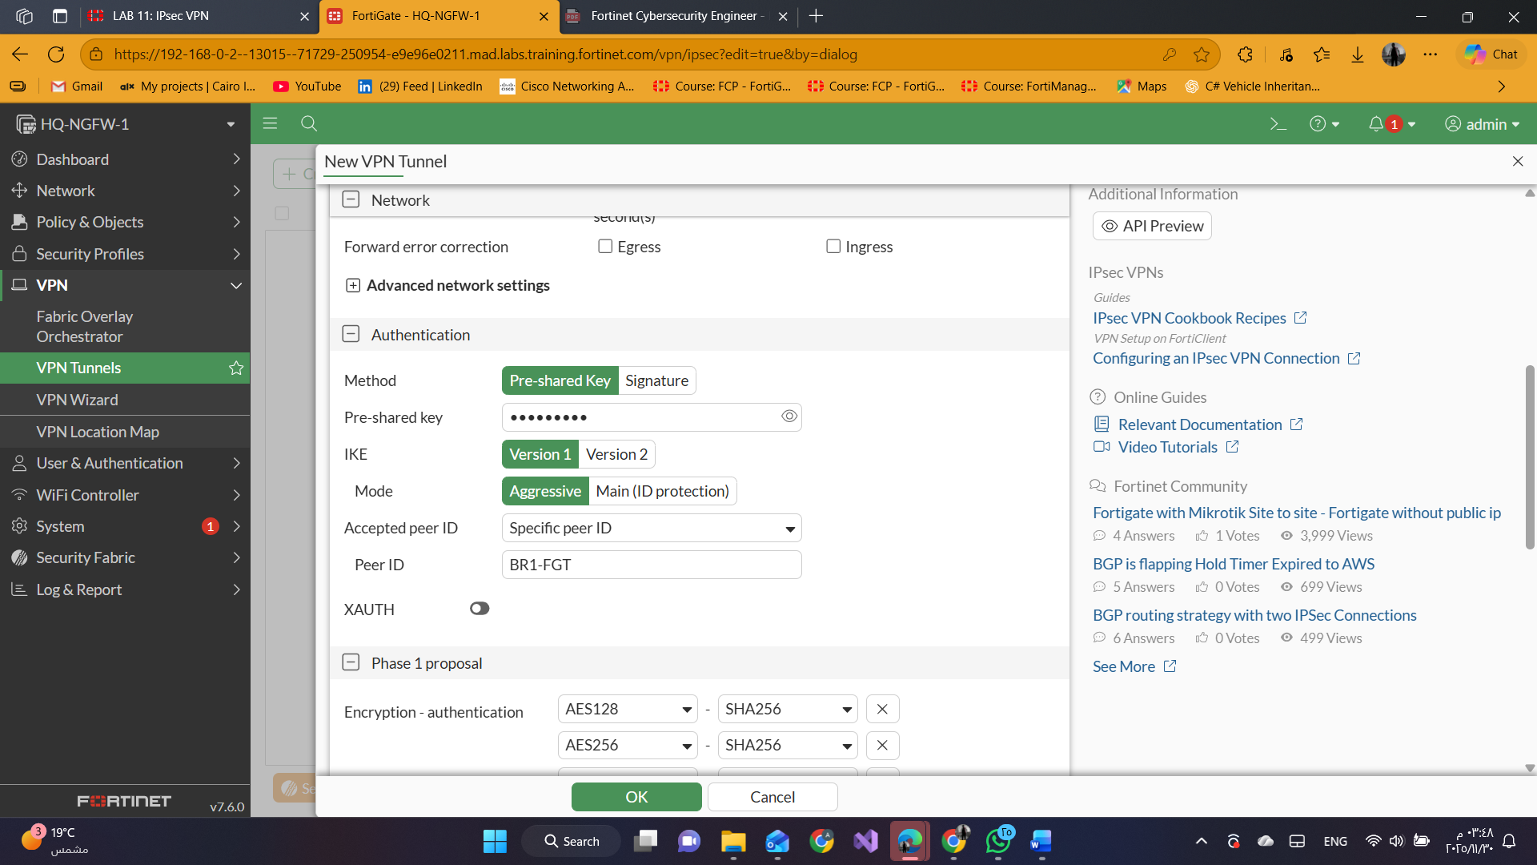

In the Phase 2 Selectors section, click **Create new**.

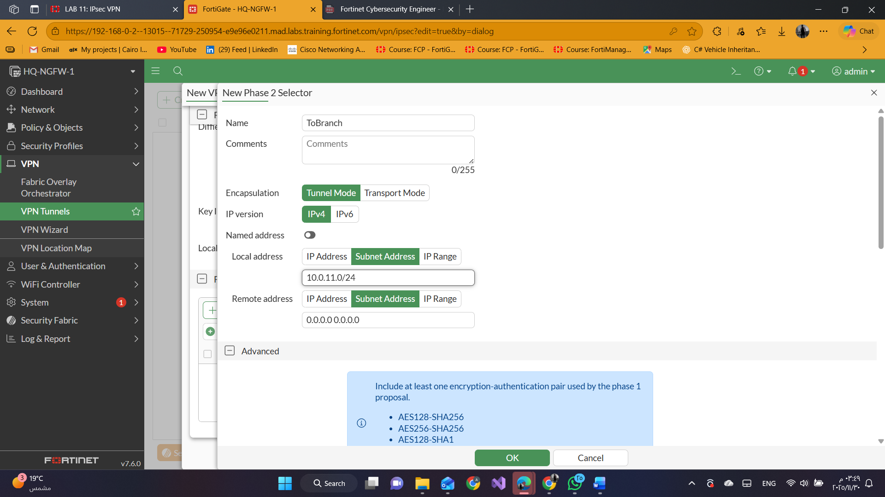

#### 2-Create Firewall Policies for VPN Traffic

**Policy** & **Objects** > **Firewall Policy** > **Create New**.

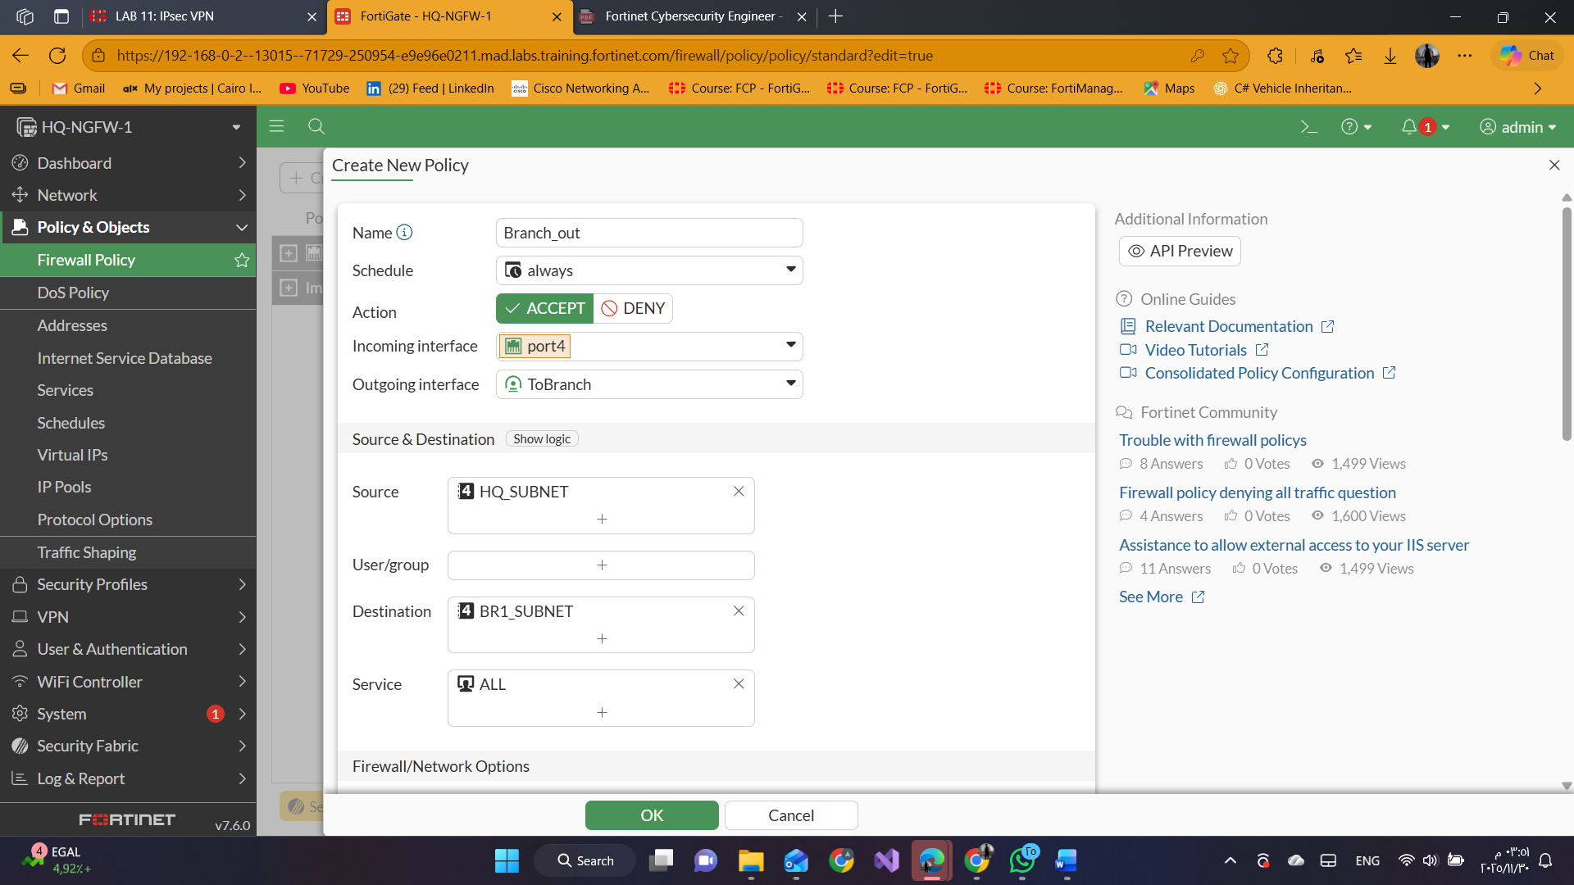

disable **NAT**

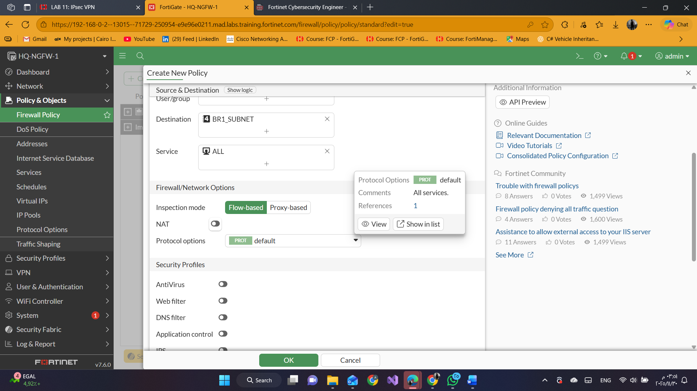

Click **OK** then Click **Create New** again.

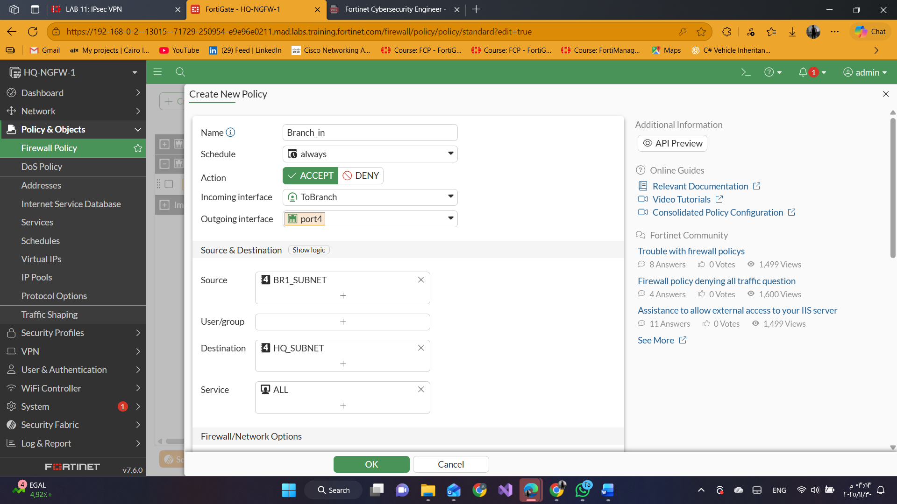

disable **NAT**



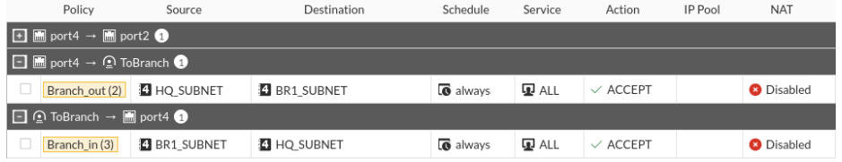

3-Create Phase 1 and Phase 2

VPN > VPN Tunnels > Create New > Custom IPsec Tunnel.

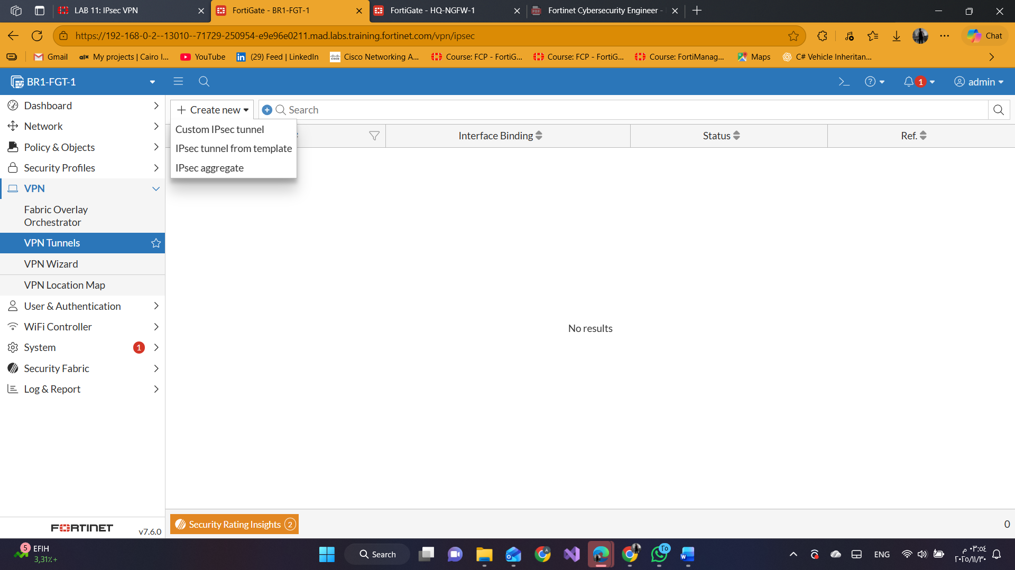

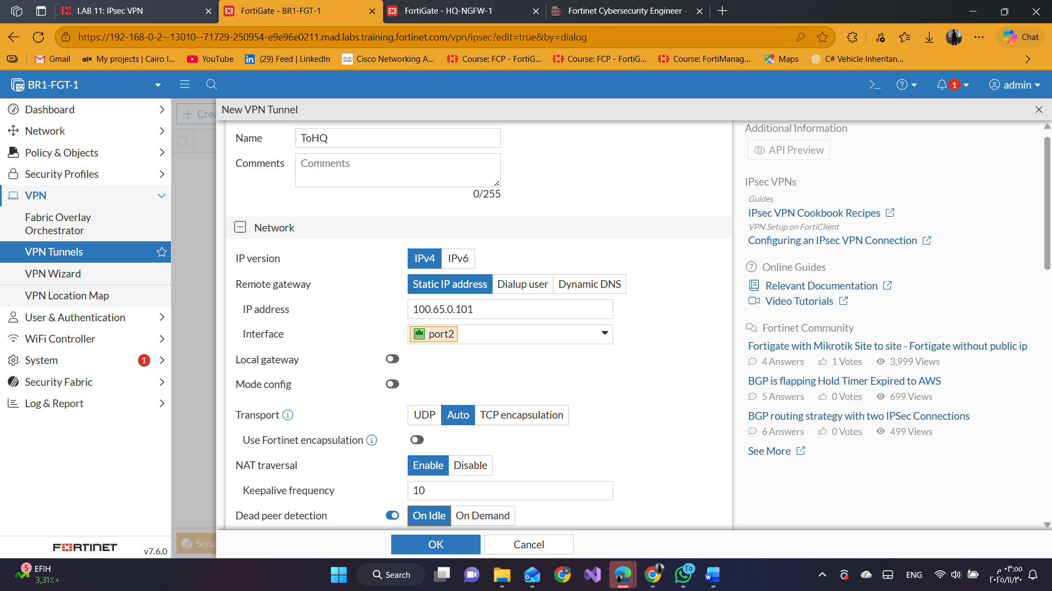

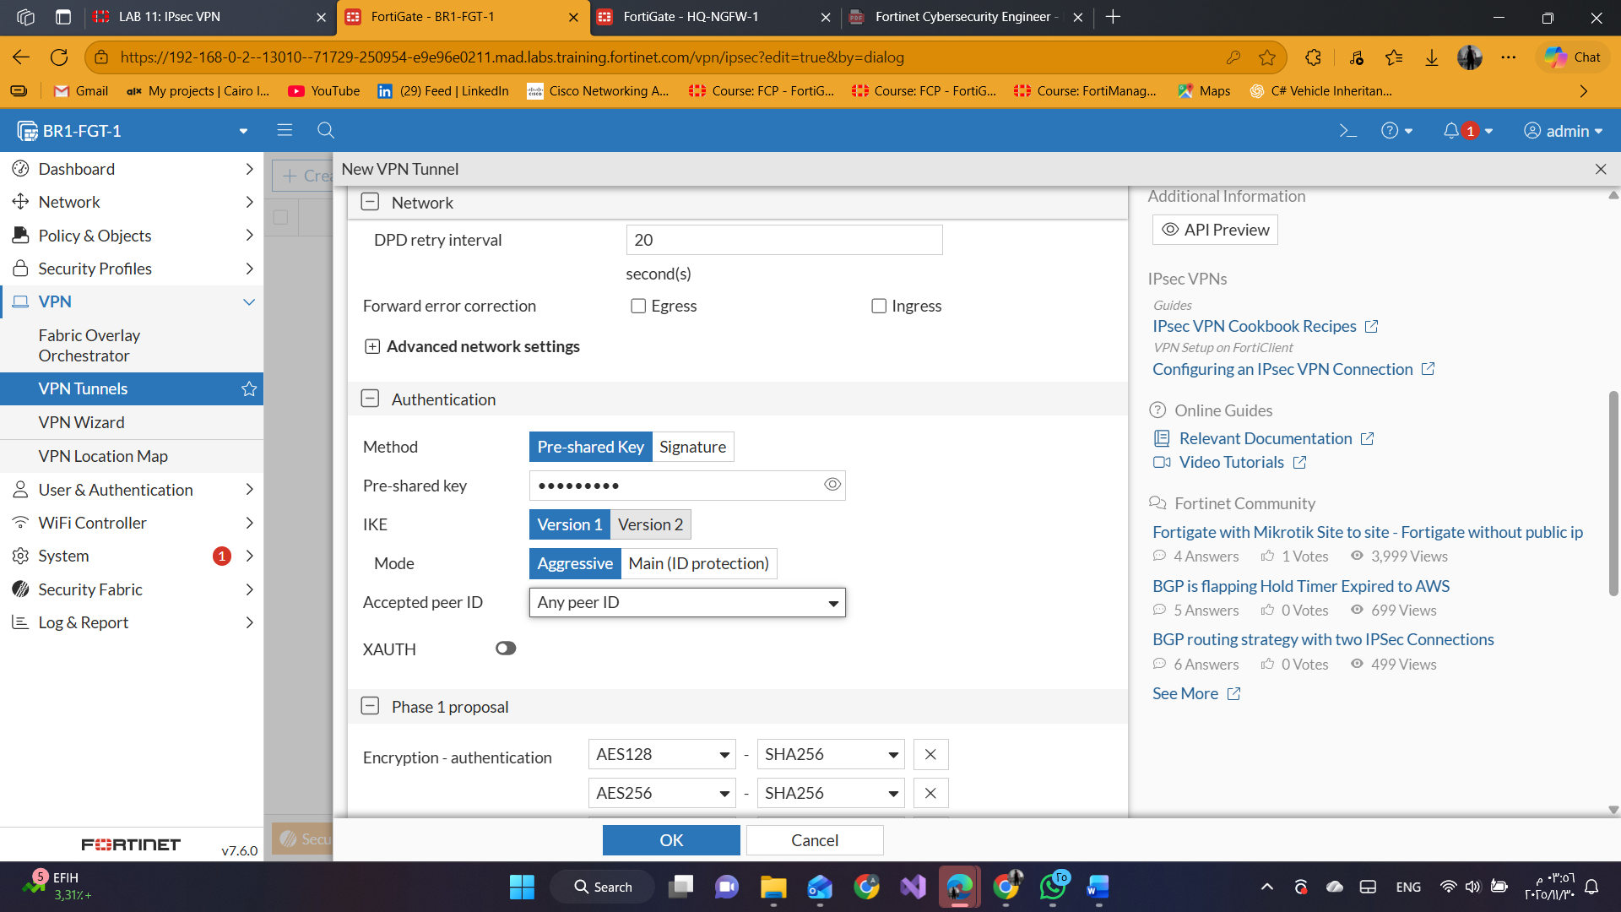

In **Phase 2** Selectors section, click **Create new**.

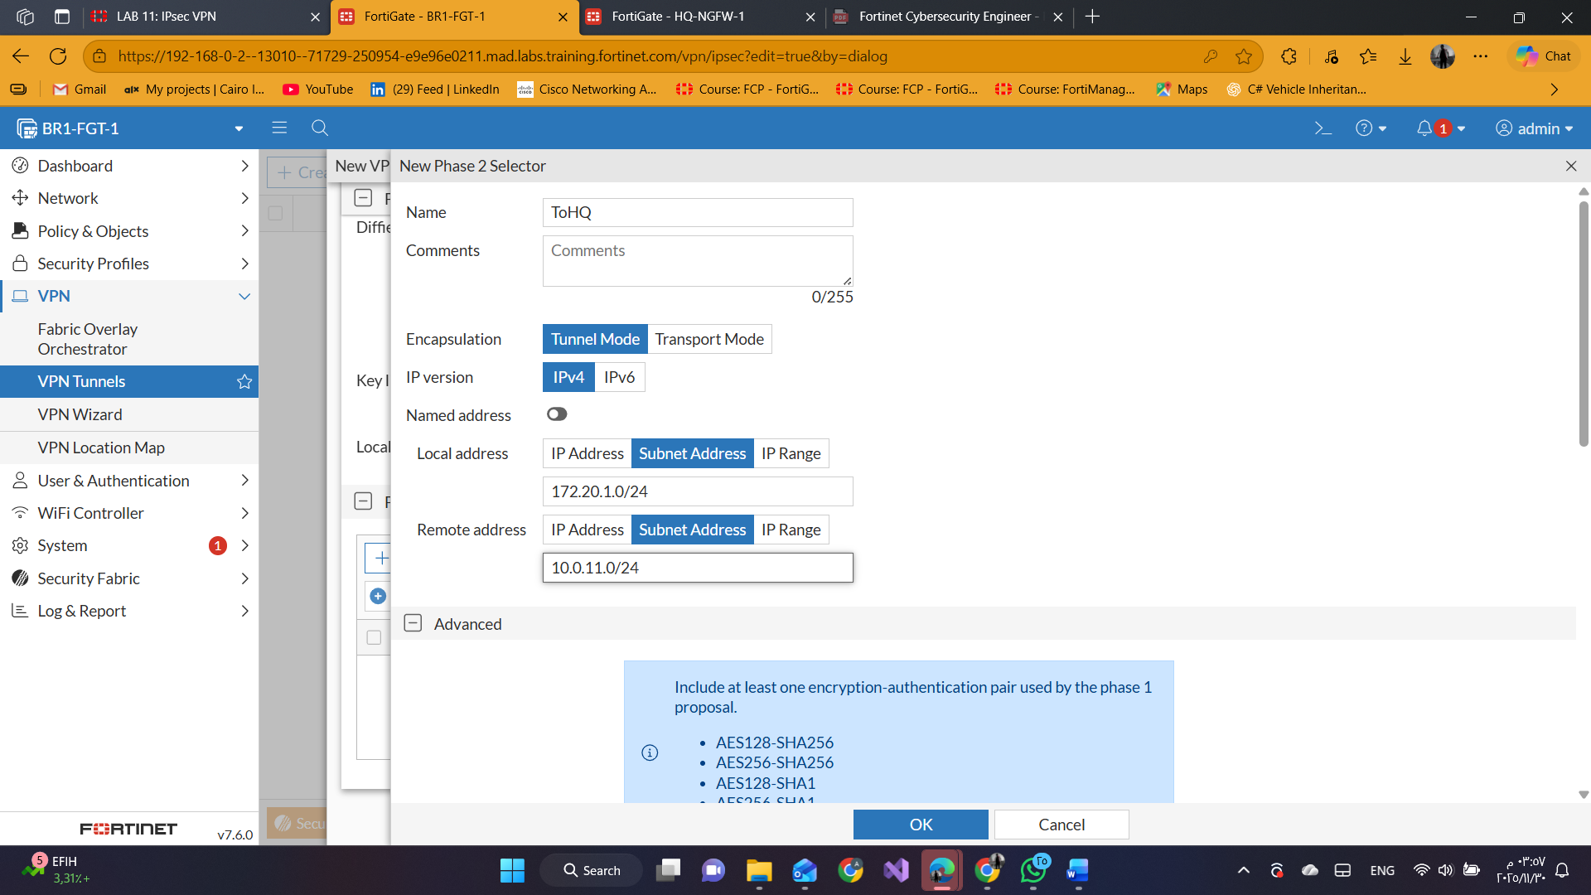

#### 4-Create a Static Route for VPN Traffic

click Network > Static Routes > Create New.

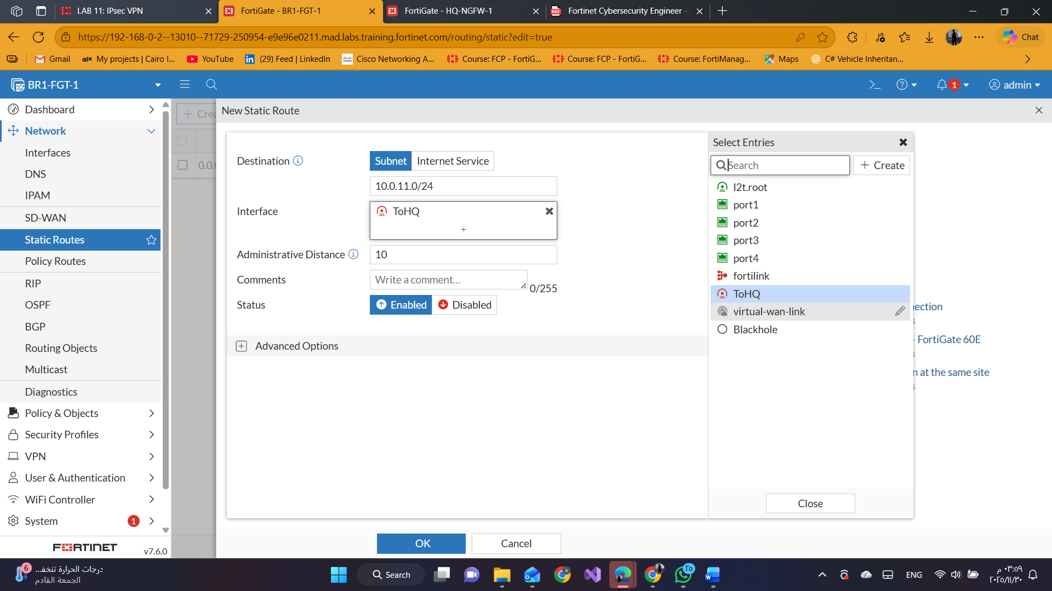

#### 5-Create the Firewall Policies for VPN Traffic

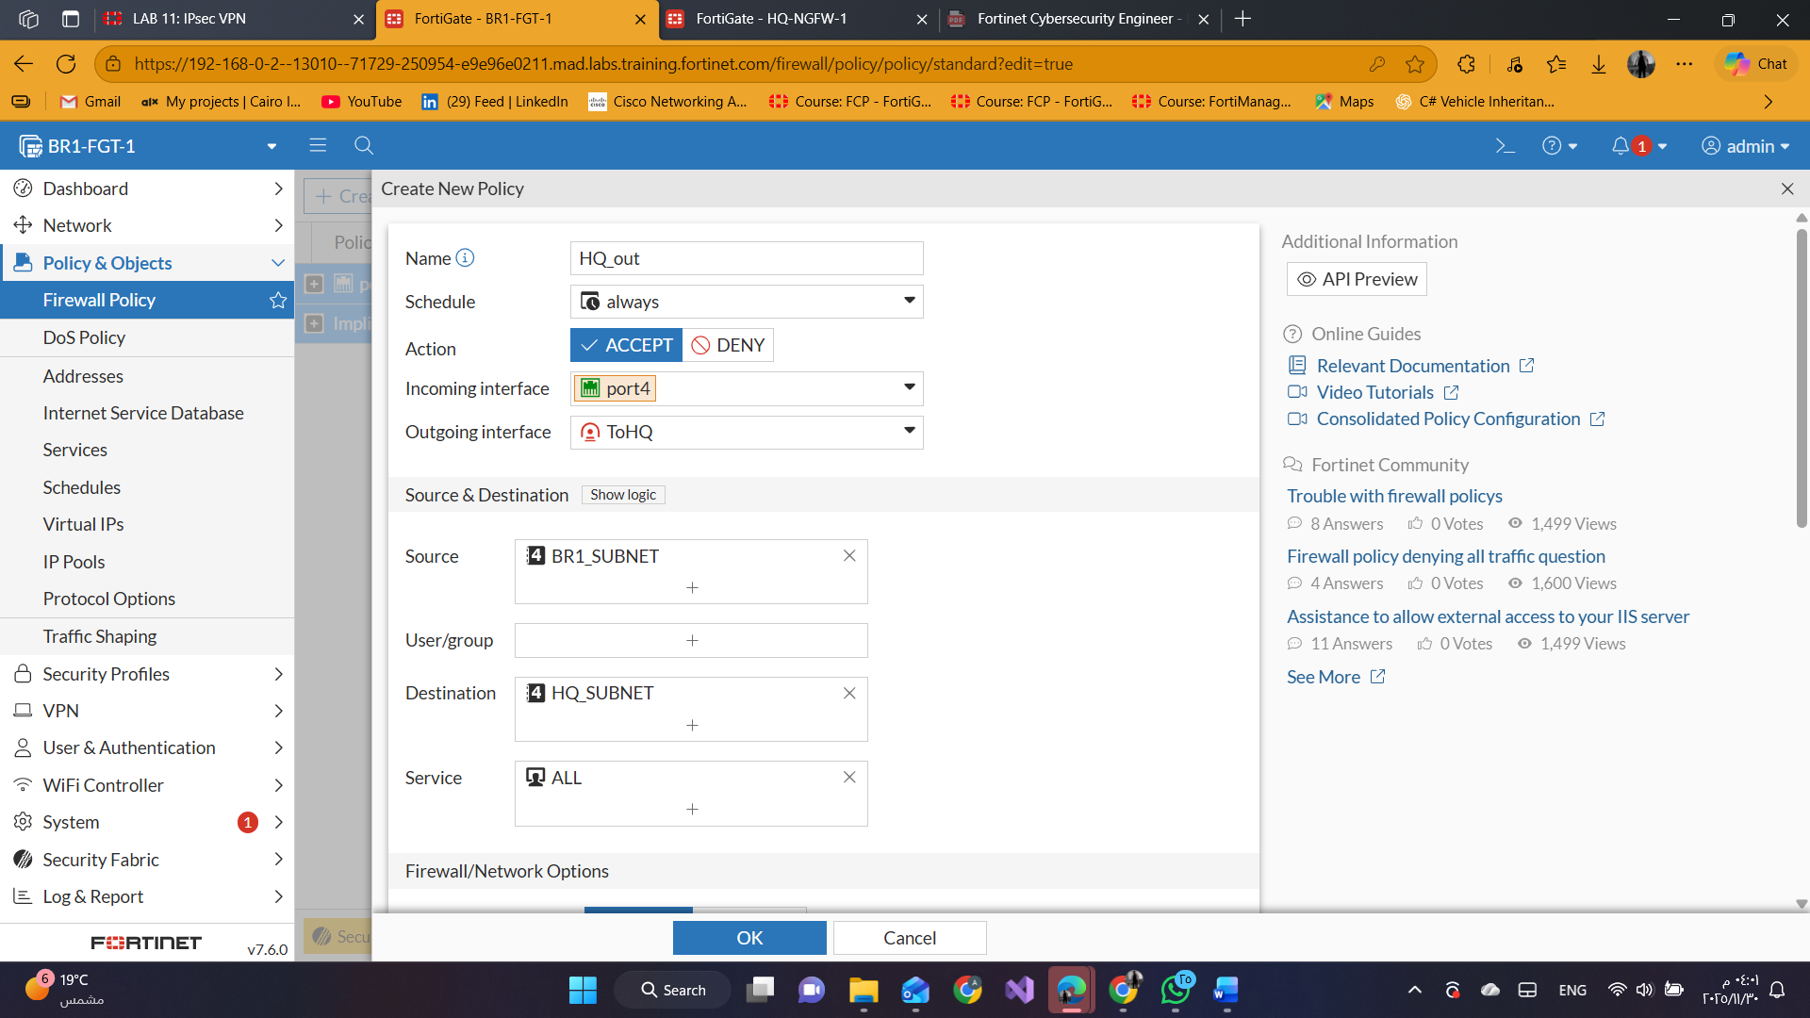

Click **Create New** again

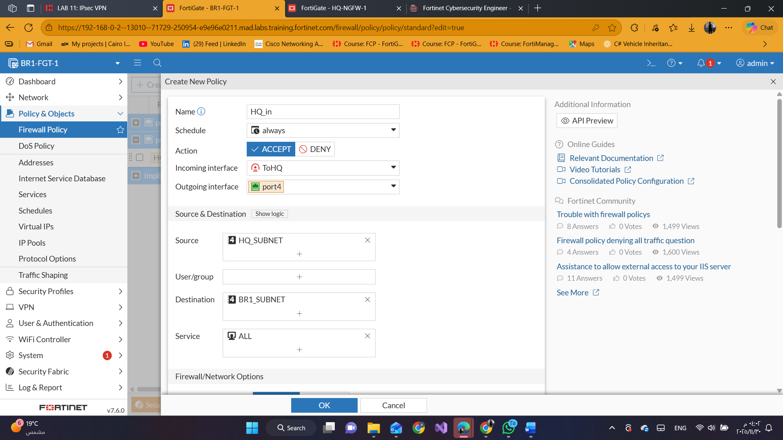

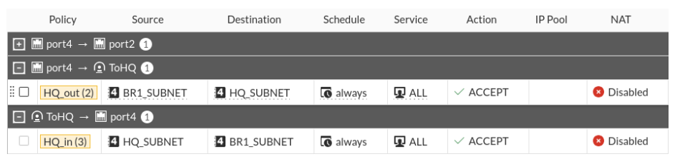

#### 6-Test and Monitor the VPN

click **Dashboard** > **Network** > **IPsec**.

Expand **Custom** to see the custom VPN tunnel entry.

The **ToHQ** VPN is currently down.

Right-click the VPN, and then select **Bring Up** > **All Phase 2 Selectors** to bring up the tunne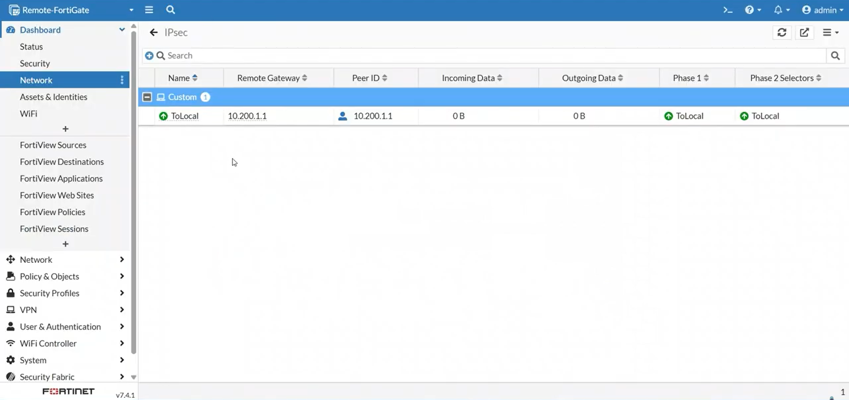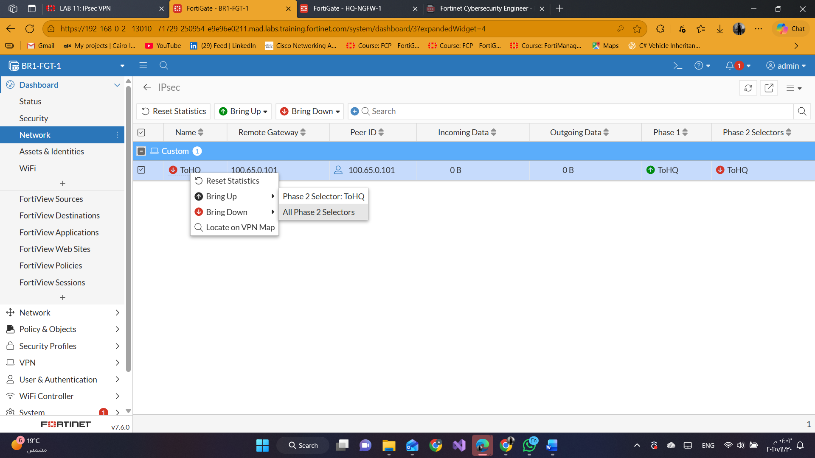

open a terminal window, and then enter the following command to ping the HQ-PC-1 VM: ping 10.0.11.50

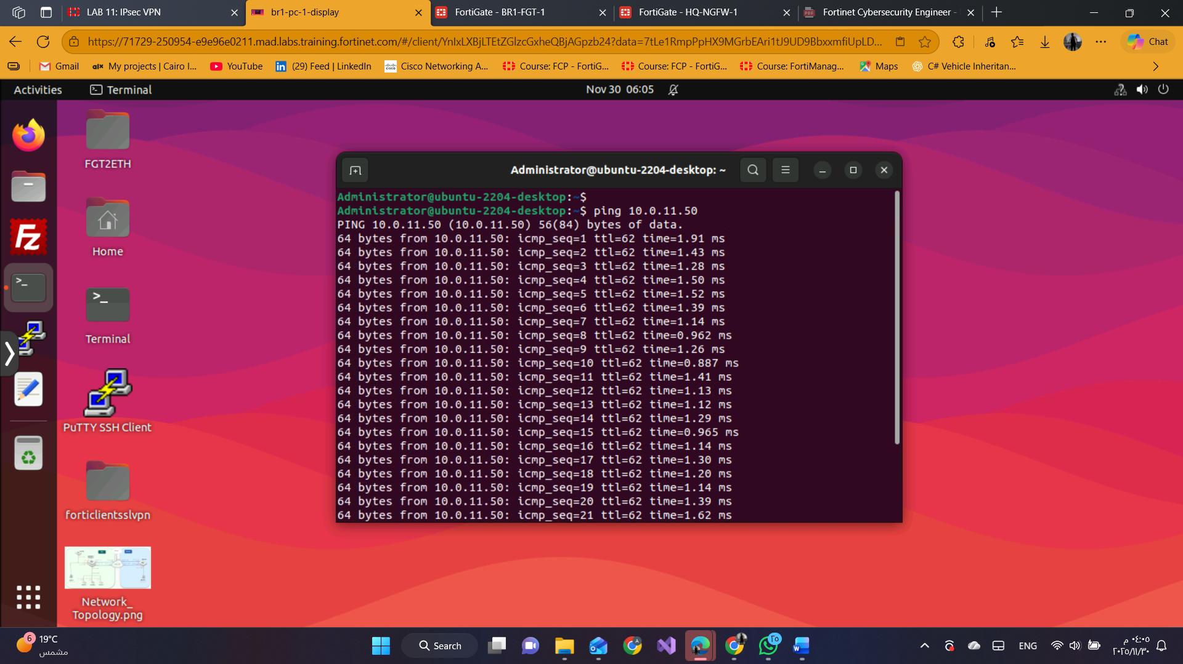

click **Dashboard** > **Network** > **IPsec**.

In the upper-right corner, click the refresh icon multiple times to refresh the widget information.

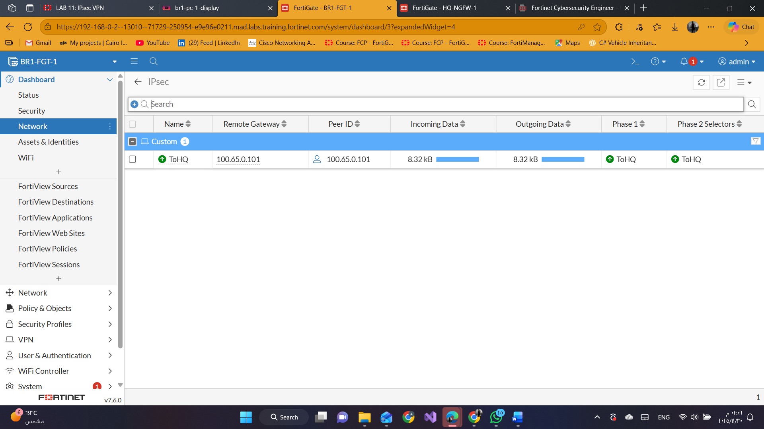

click **Dashboard** > **Network** > **Static & Dynamic Routing**.

1. Find the static route that was dynamically added to the FortiGate.
2. View the route details.
3. Notice the address listed in the **Gateway IP** column for that route.

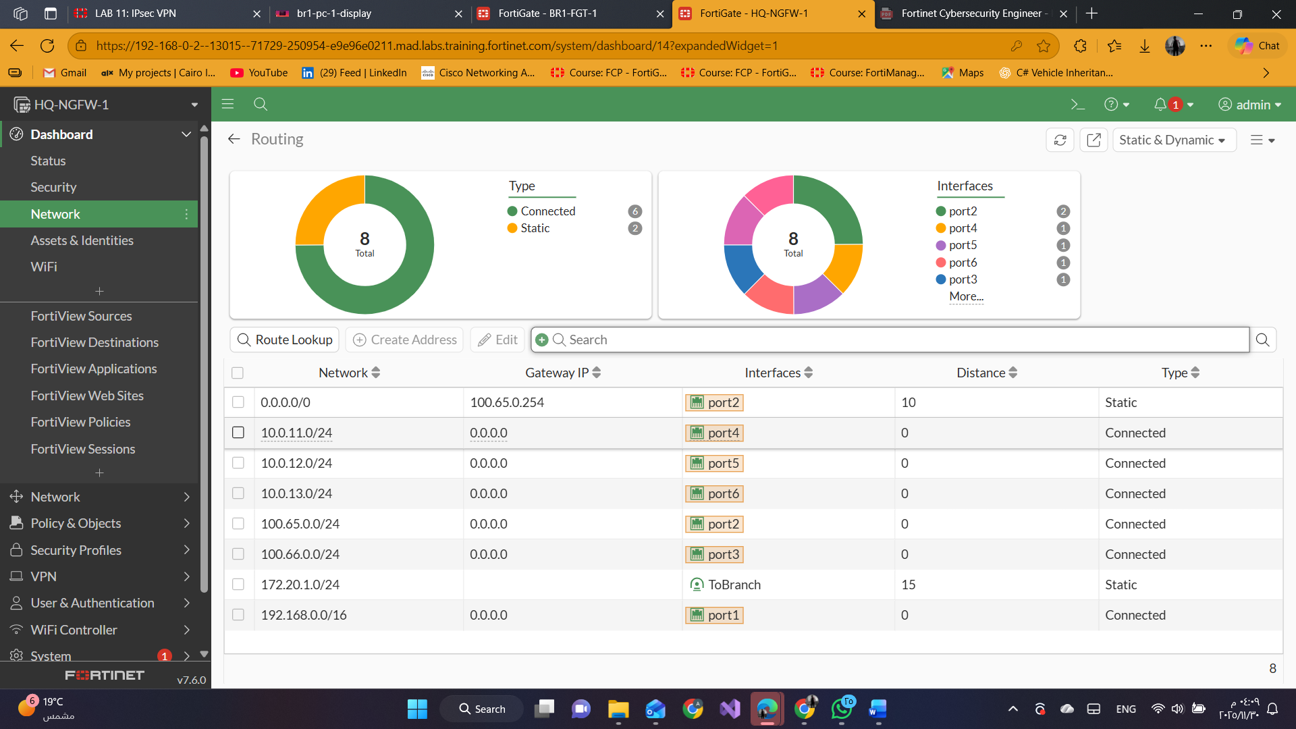

### Configuring a Static IPsec VPN Between Two FortiGate Devices

restore the HQ-NGFW-1 configuration file

**admin** > **Configuration** > **Revisions**.

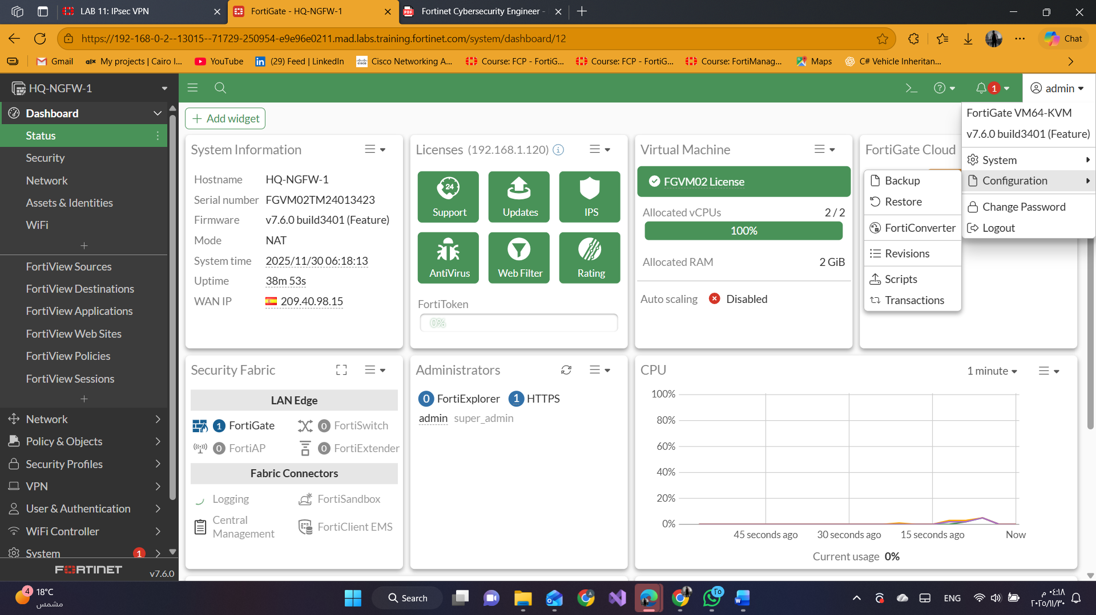

Select the configuration with the comment **HQ-static-ipsec**, and then click **Revert**.

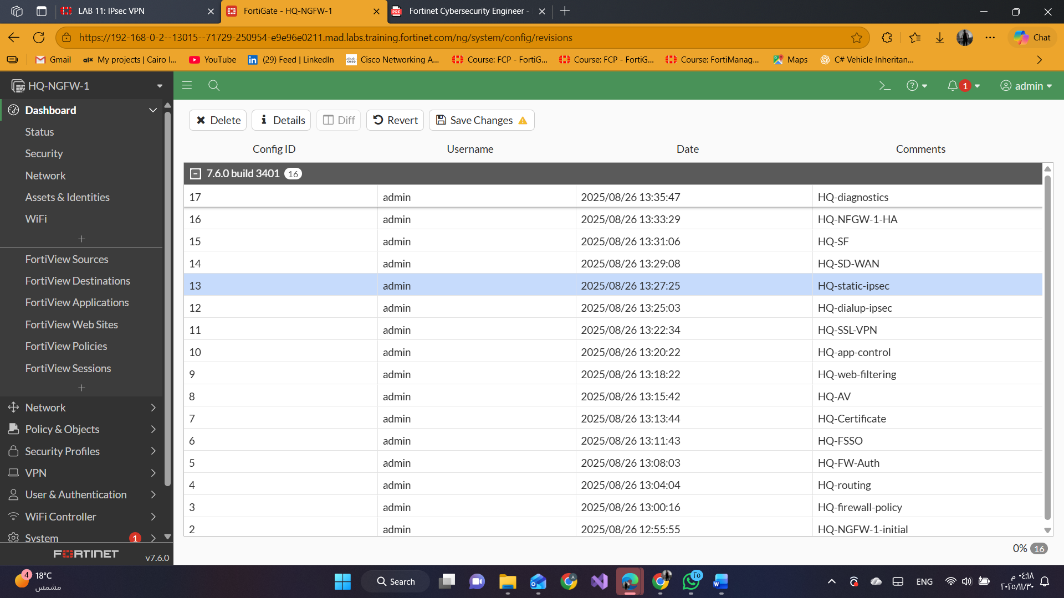

#### Create Phase 1 and Phase 2 Negotiations

Click **VPN** > **VPN Tunnels** > **Create New** > **Custom IPsec tunnel**.

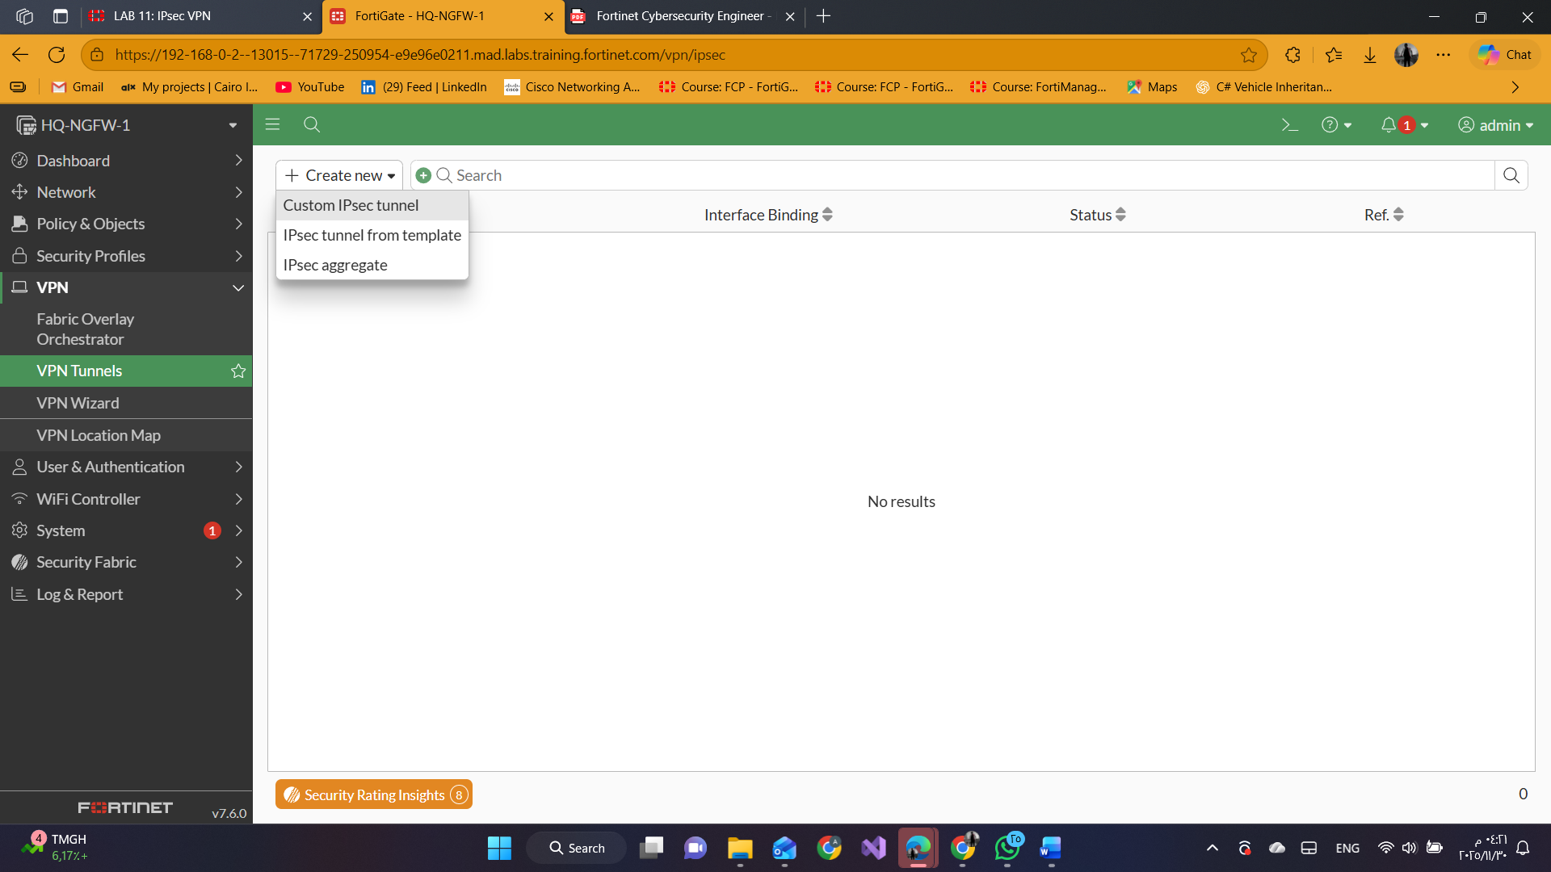

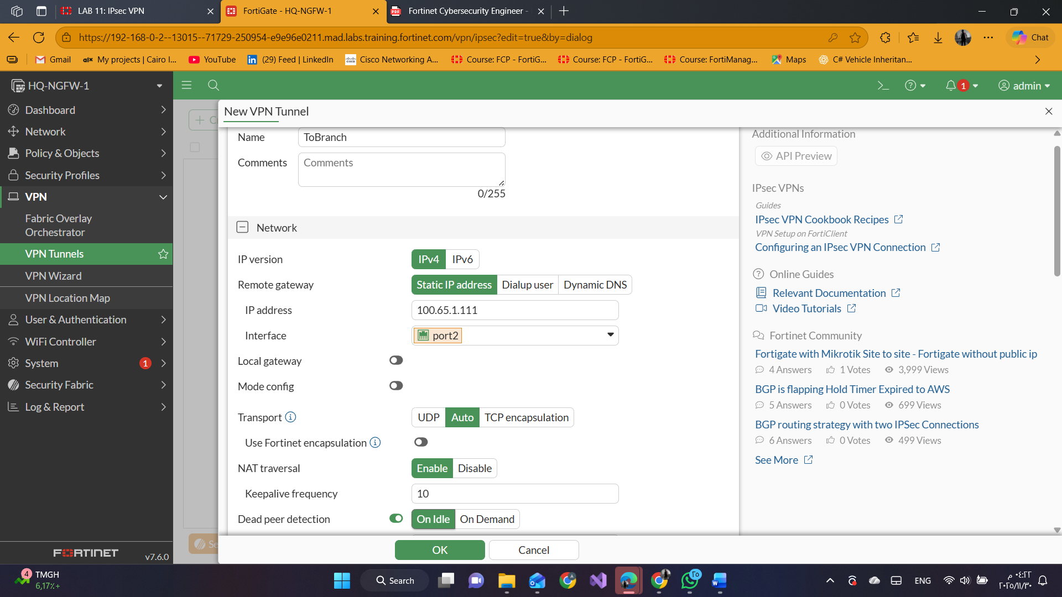

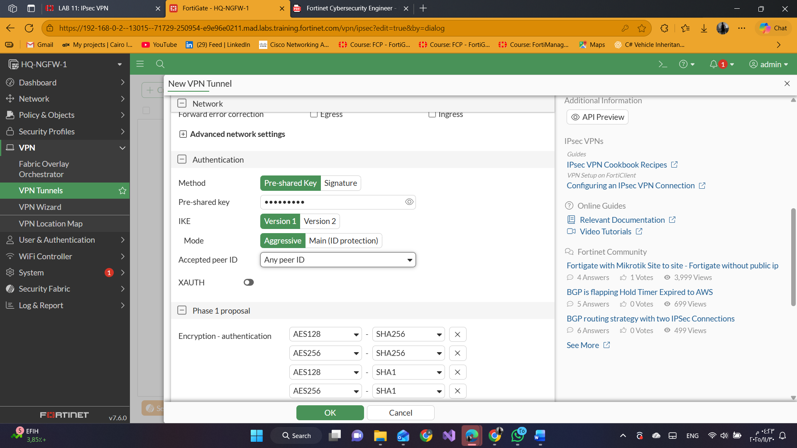

In the **Phase 2 Selectors** section, click **Create new**

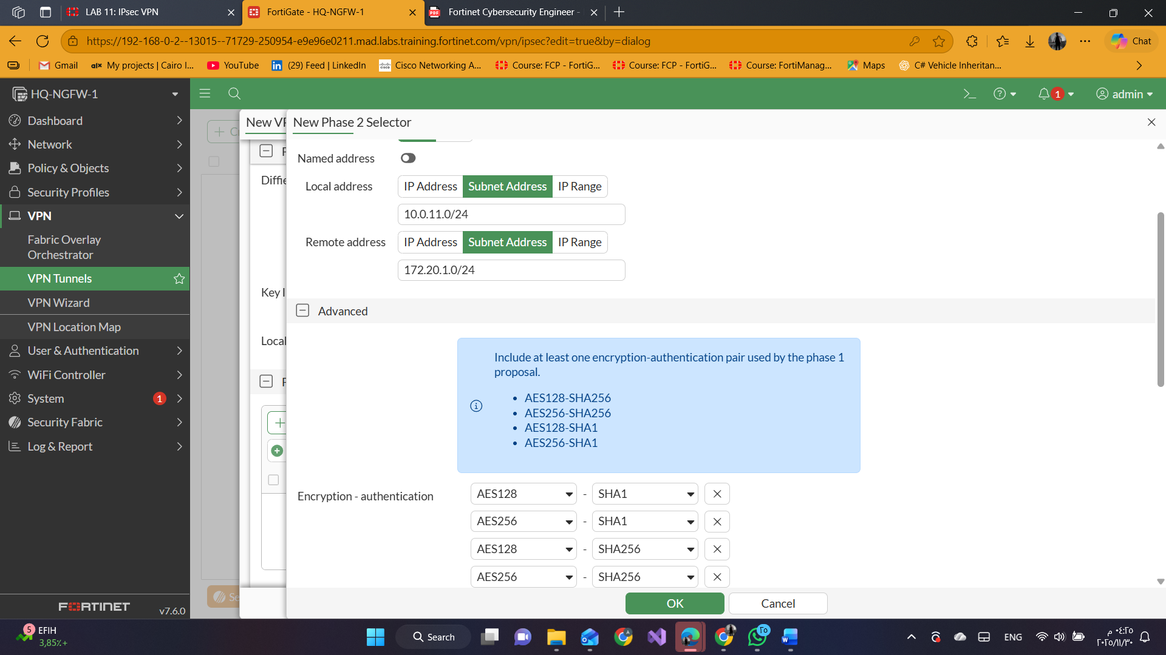

#### **3-Create a Static Route for VPN Traffic**

1. click **Network** > **Static Routes**.
2. Click **Create New**.

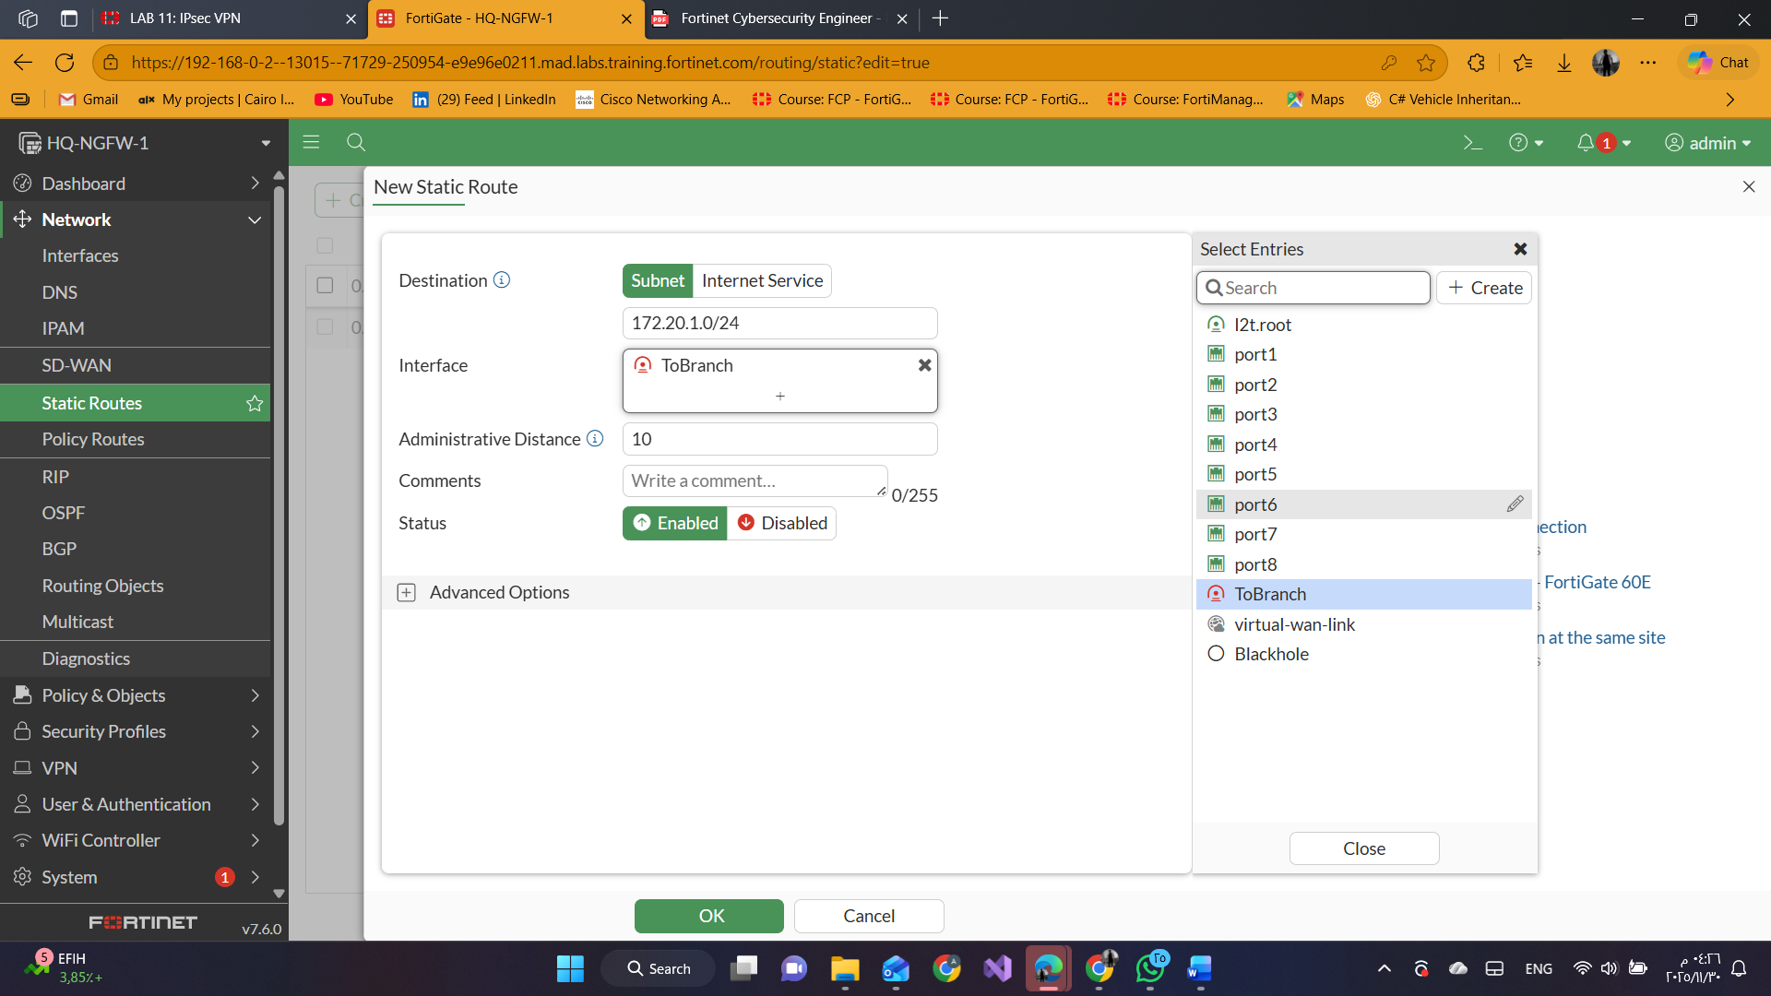

#### **4-Create Firewall Policies for VPN Traffic**

1. click **Policy** & **Objects** > **Firewall Policy**.
2. Click **Create New**.

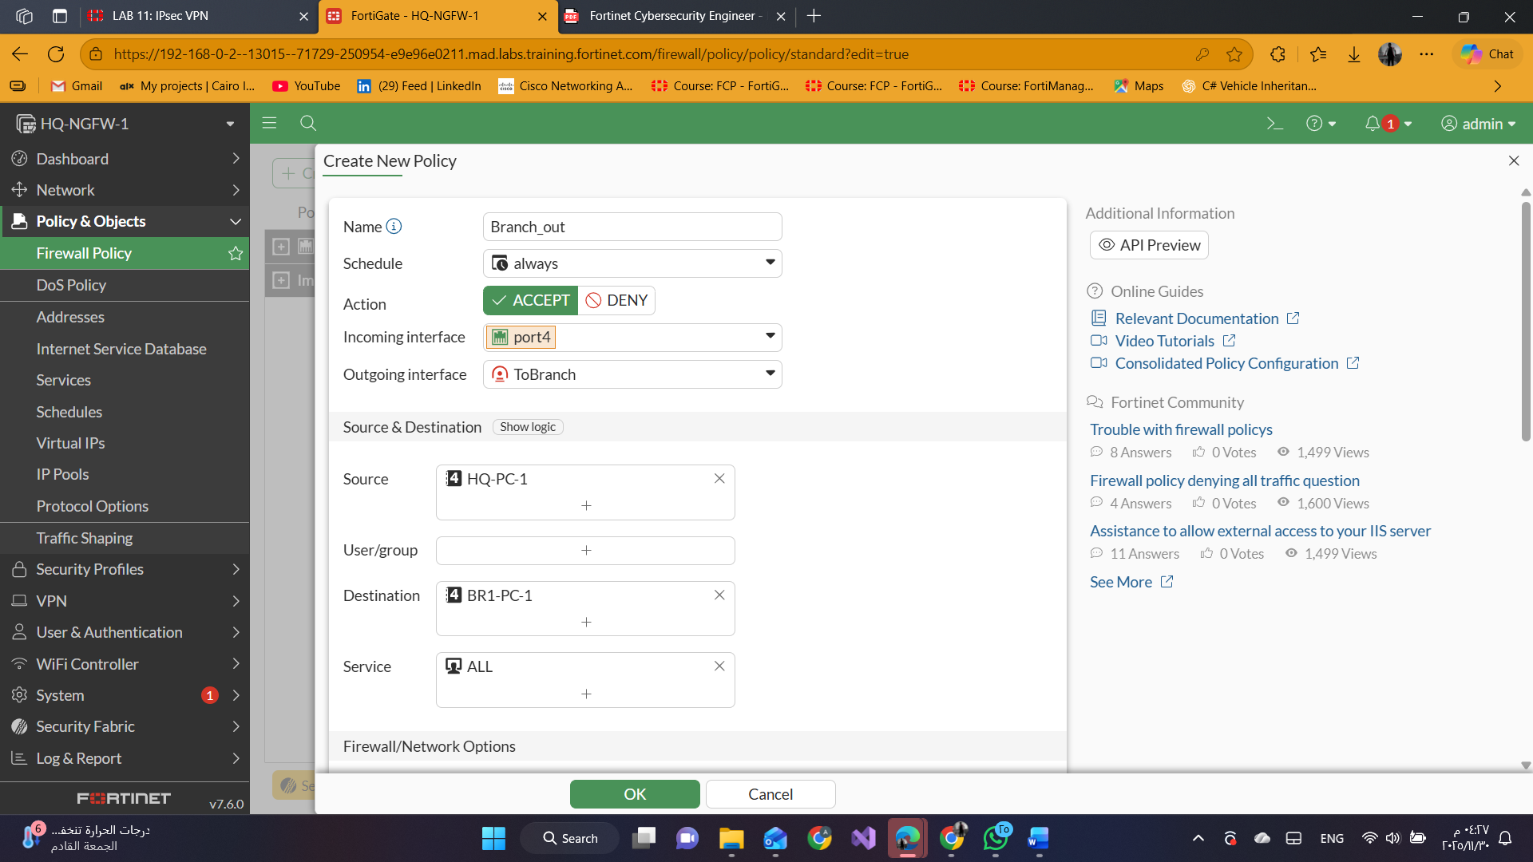

1. Click **OK**.
2. Click **Create New** again.

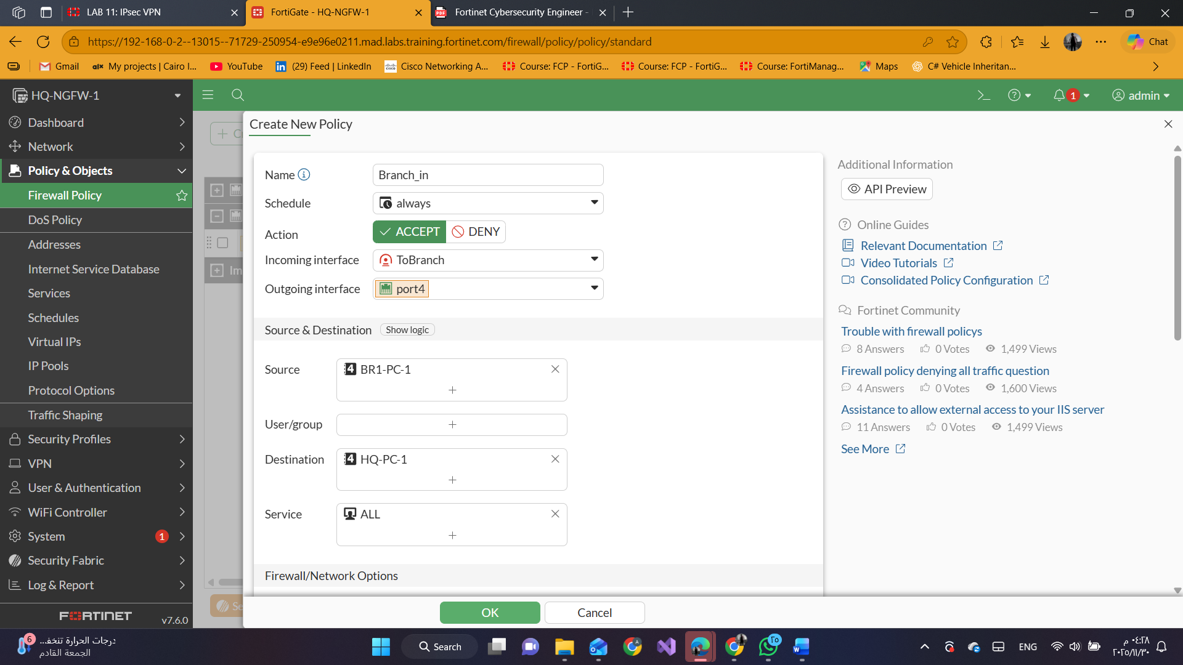

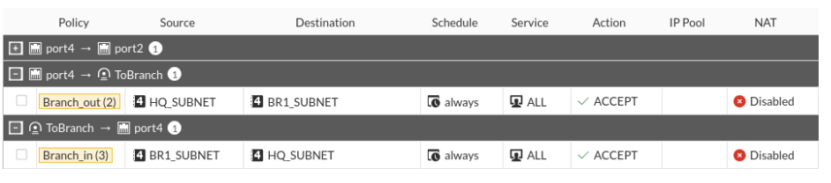

#### **5-Test and Monitor the VPN**

1. click **Dashboard** > **Network** > **IPsec**.
2. Expand **Custom** to show the custom VPN tunnel entry.

The **ToBranch** VPN is currently down.

3.Right-click the VPN, and then select **Bring Up** > **All Phase 2 Selectors**.

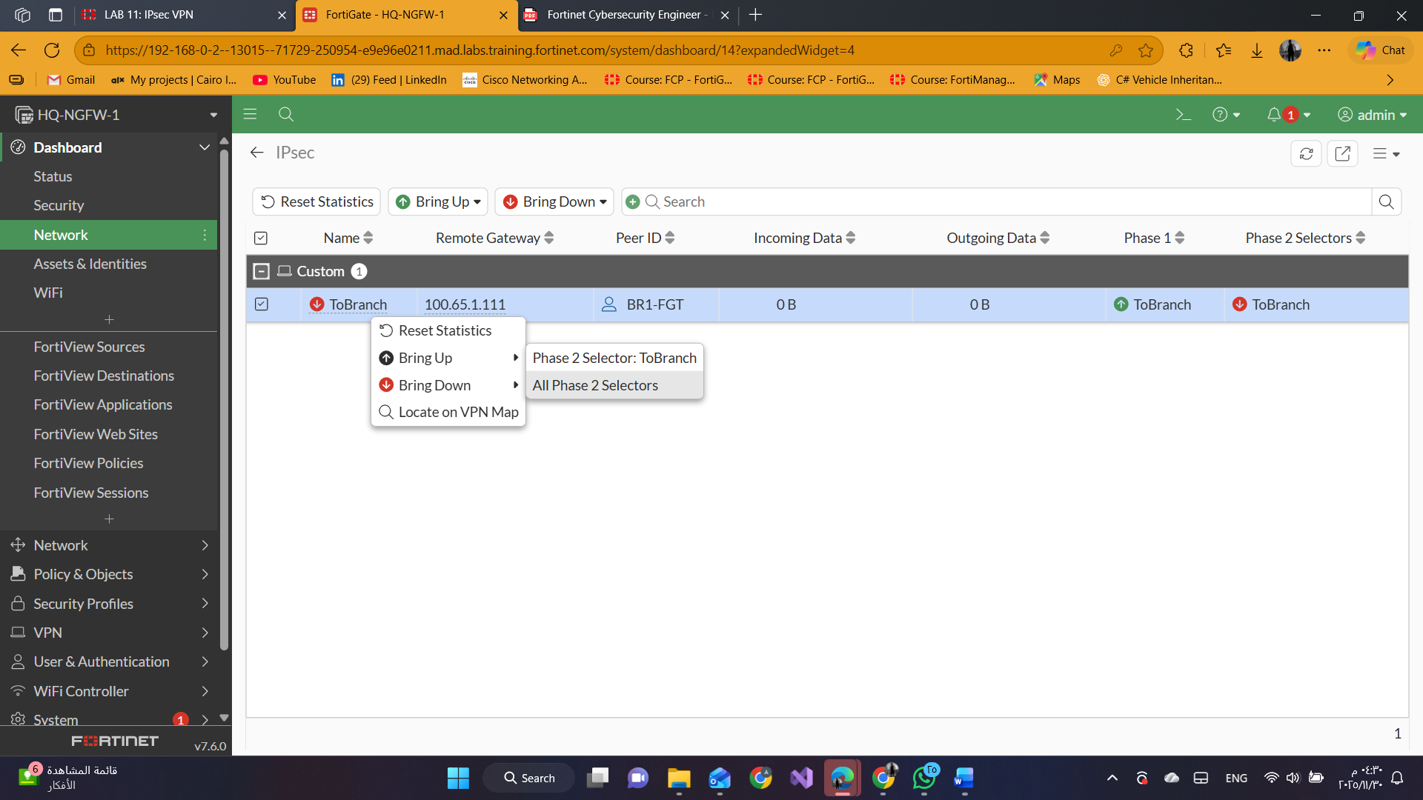

open a terminal window, and then enter the following command to ping the HQ-PC-1 VM:

ping 10.0.11.50

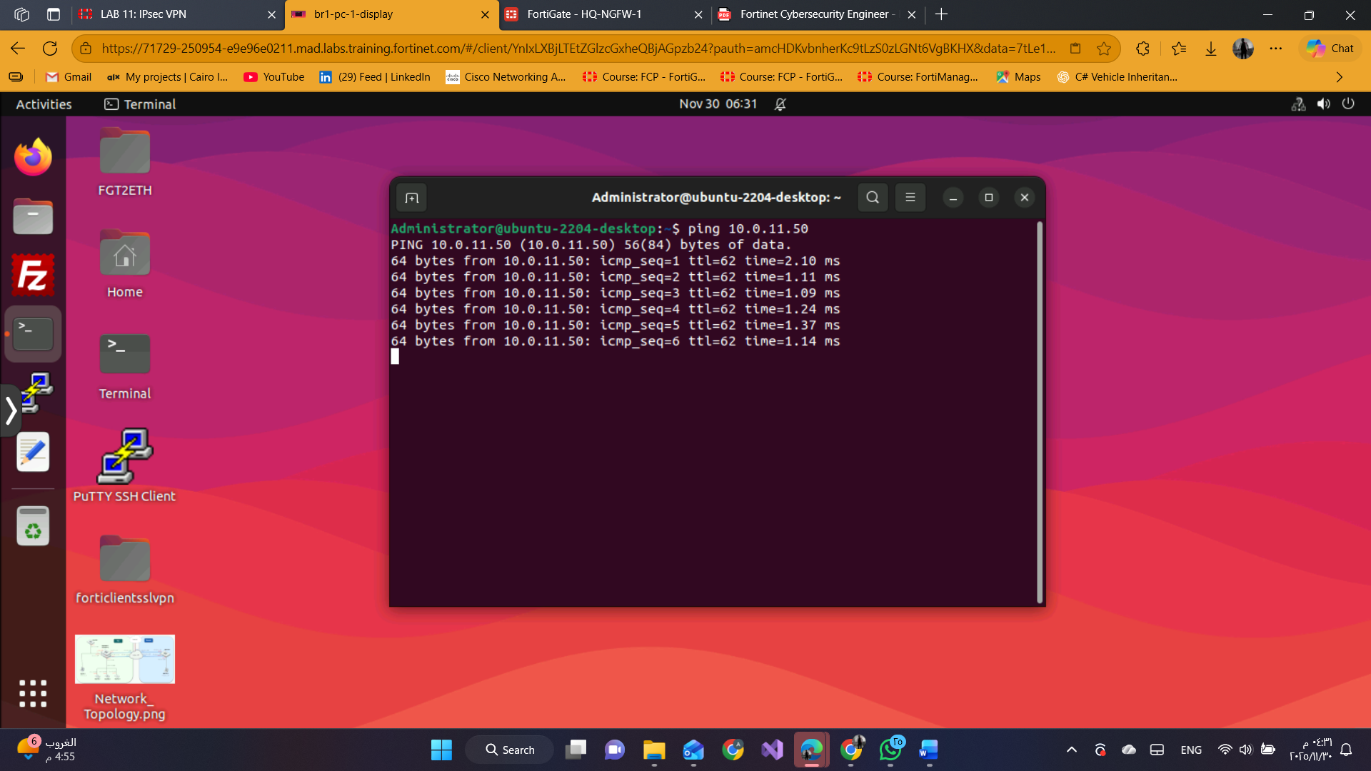

1. click **Dashboard** > **Network** > **IPsec**.
2. In the upper-right corner, click the refresh icon multiple times to refresh the widget information.

